Part 1 — Configure Secure IAM Access
- Go to IAM Users > Select the User that you want to apply the MFA on it , Write the Device Name , and select MFA Device ( I Choose Authenticator app as it is a popular way to make MFA Codes) , then go to your Phone Download Google Authenticator and Scan a QR code that will displayed when you press next in your consol , Google Authenticator in your phone will gives you two Codes write them on MFA code 1 and MFA code 2 and then press finish

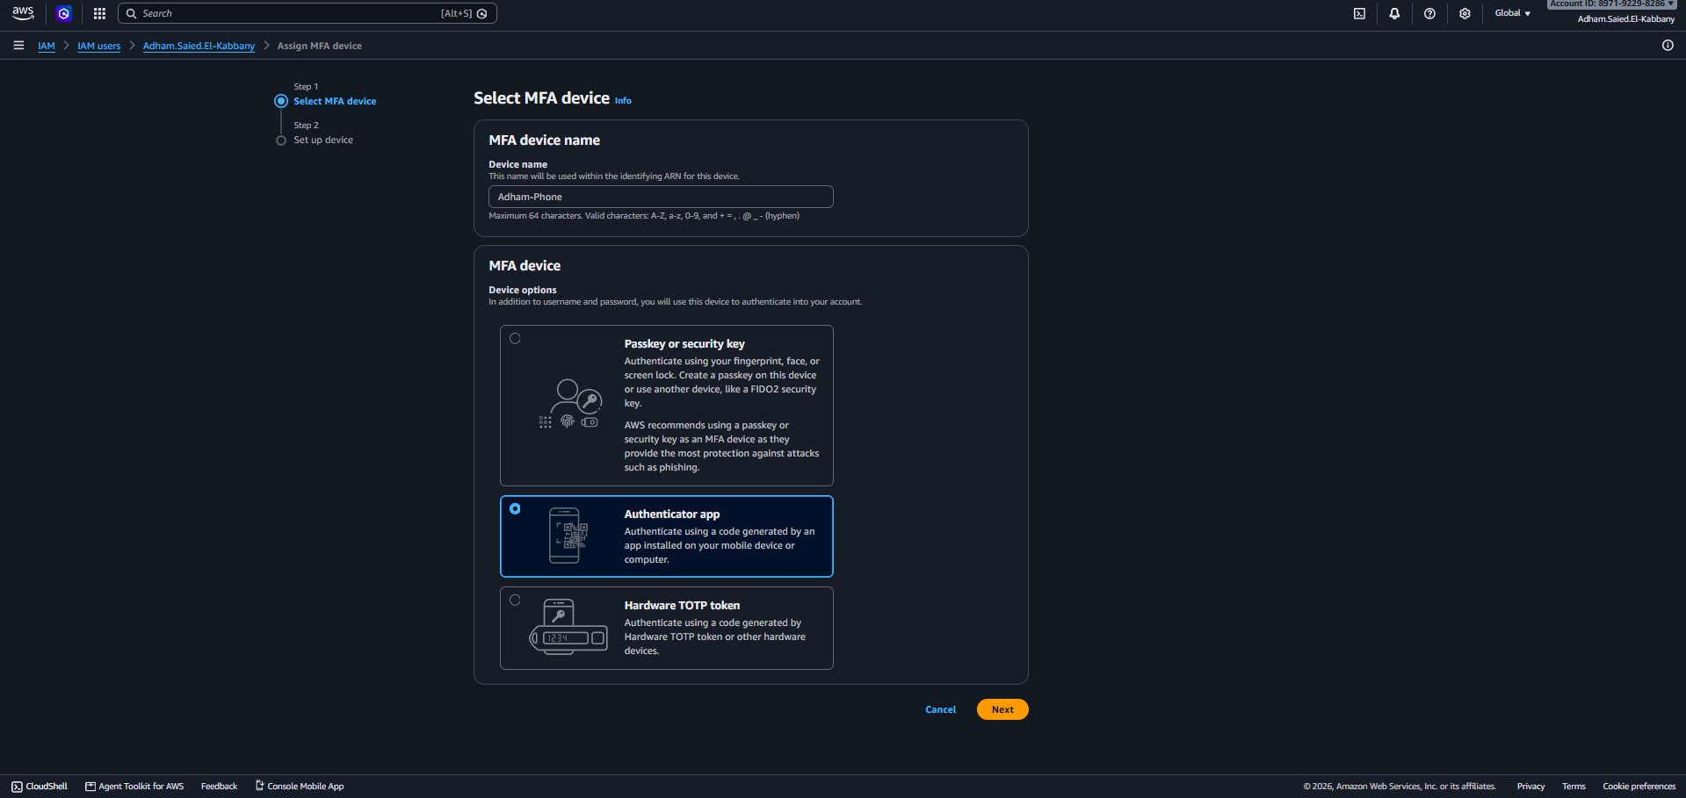
- Now this green rectangle says that MFA Device successfully assigned
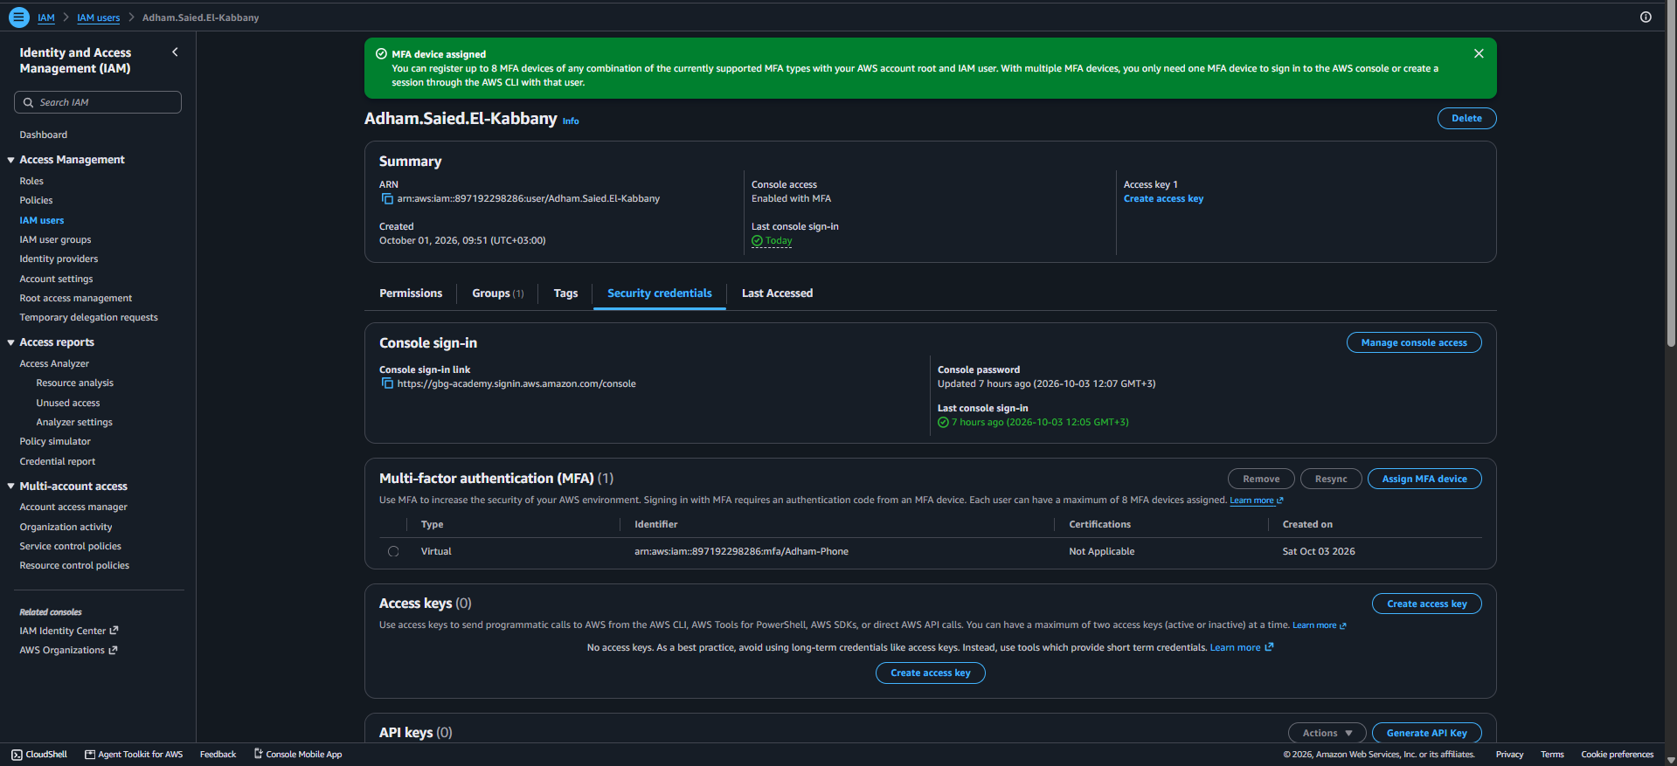
- Tring to attaching the policy that enforce MFA compliance as required to the IAM Group but there is a restrictions that deny to attach a policy to IAM Group So I will try another method.
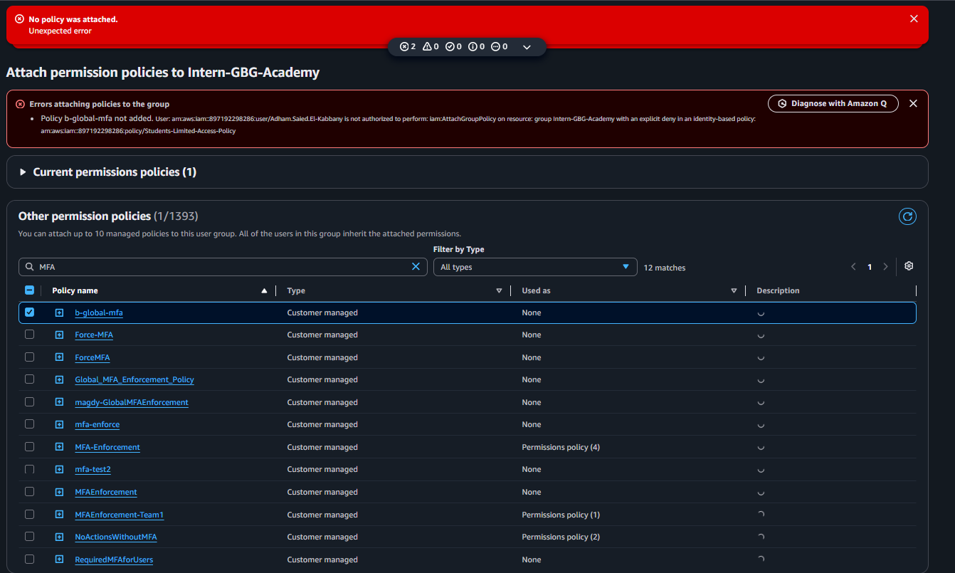

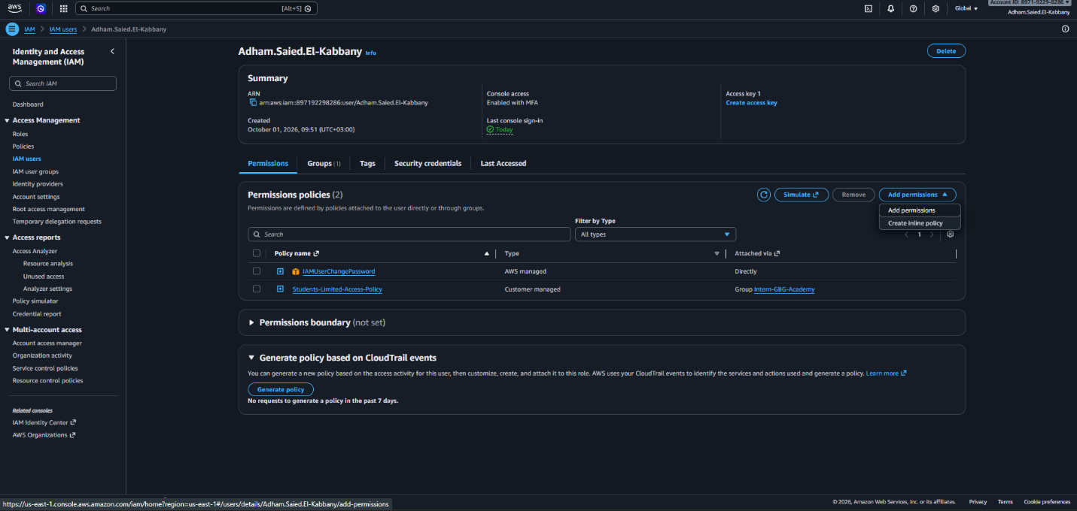
- Go to IAM Users > Select the User that you want to attach the policy on , at permissions tab select add permissions

- Select Attach policies directly that listed on right of the page , then search for the name of the policy that you want to attach ( I used NoActionsWithoutMFA ) as its JSON policy confirmed that it enforces a strict Deny on all AWS actions ,while explicitly allowing MFA device management actions so the user is not locked out, check it and then press next.
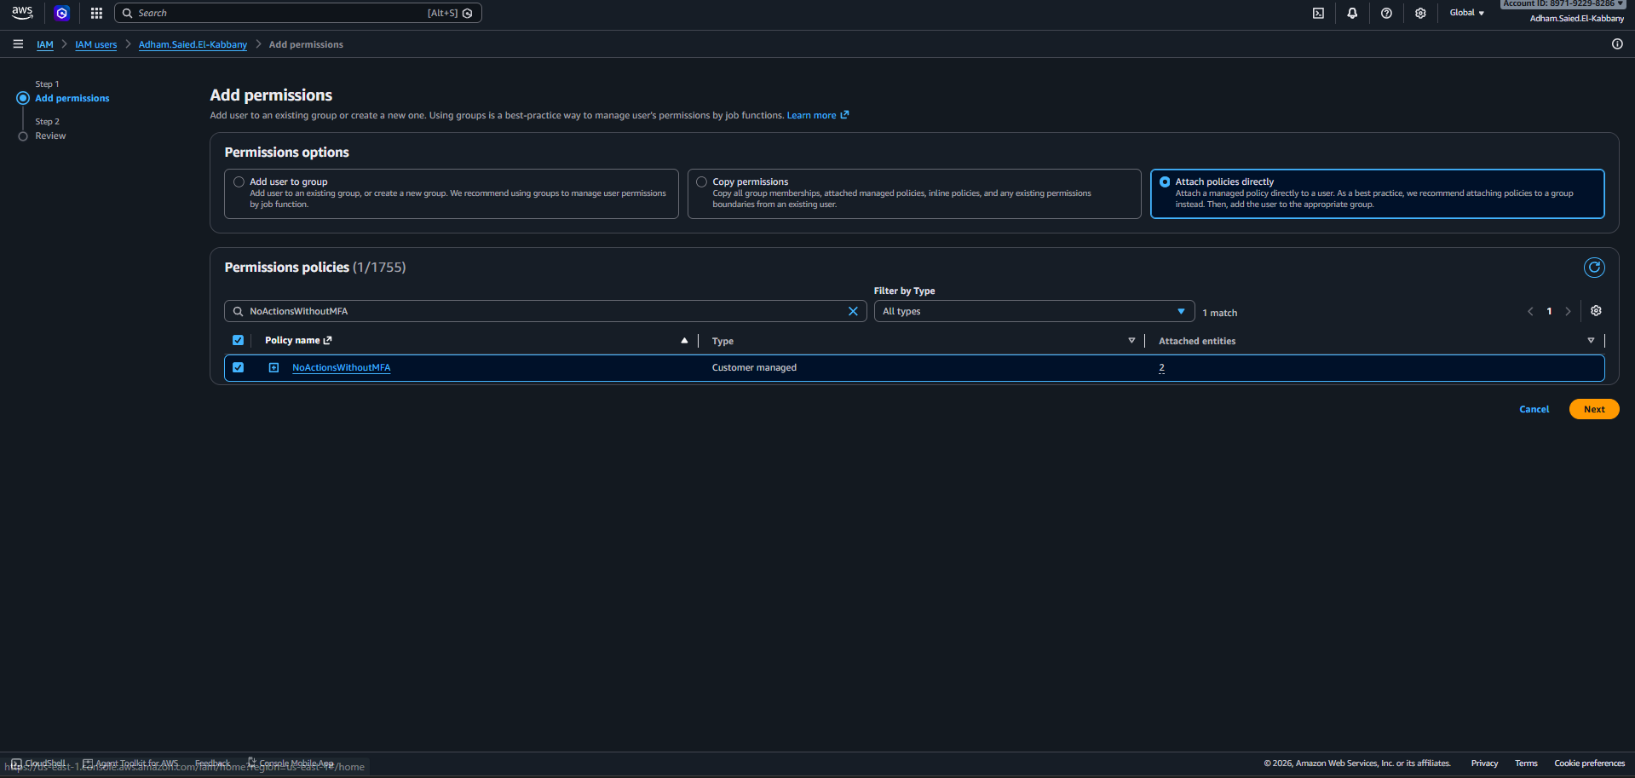

- Review and press add permission.
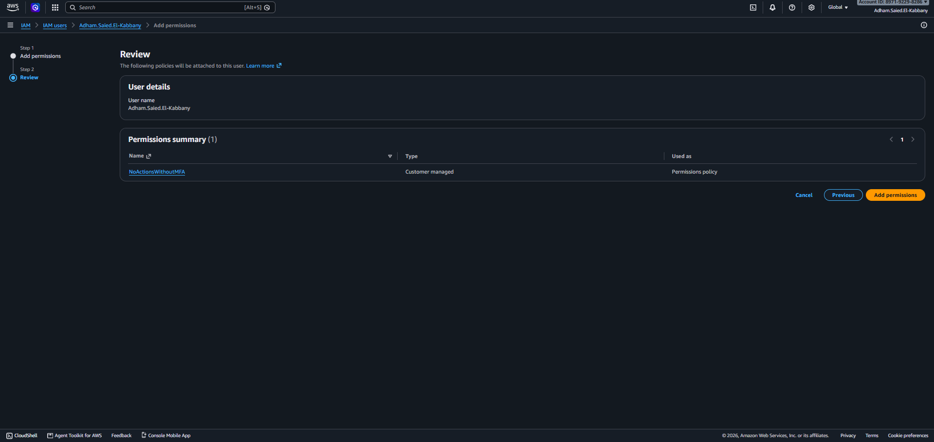

- The policy successfully added to the IAM User.
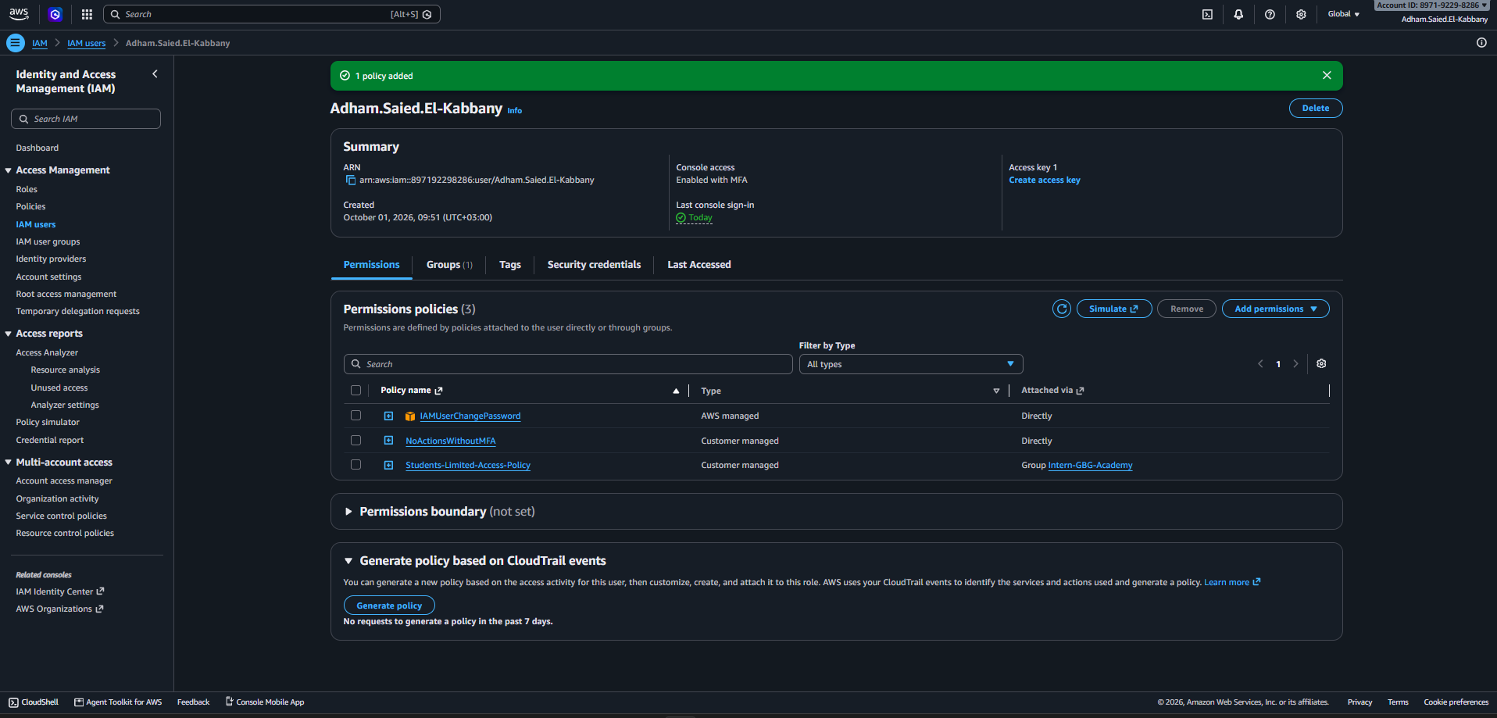

- To make sure that all matches true go to private window and try to sign in with your user
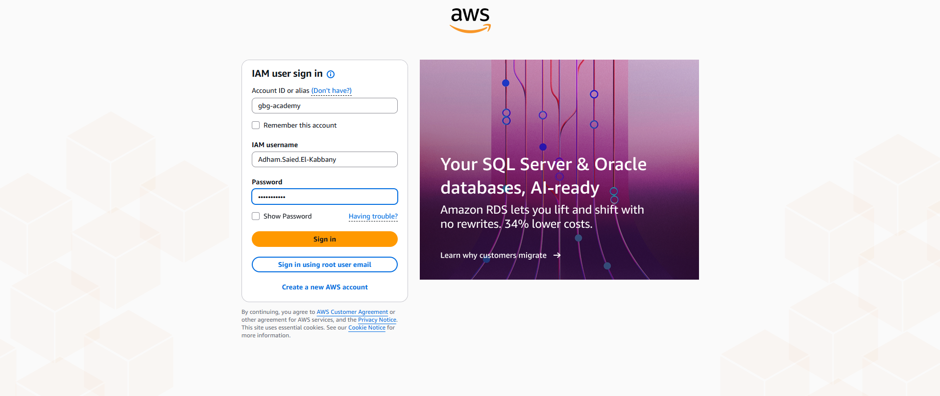

- MFA Code is required to sign in

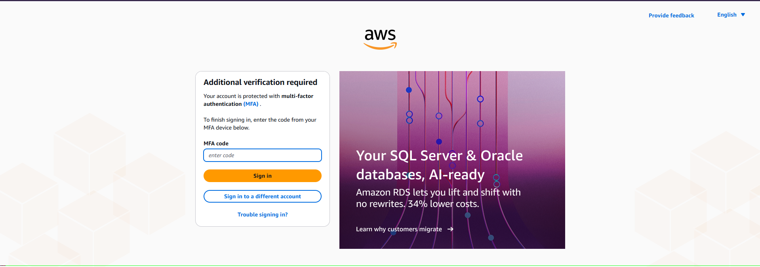

- Step 2 (Read-Only Group & User Creation)
I tried to create an IAM Group called ReadOnlyGroup and assign the required permissions. The action was denied because of the (Students-Limited-Access-Policy).
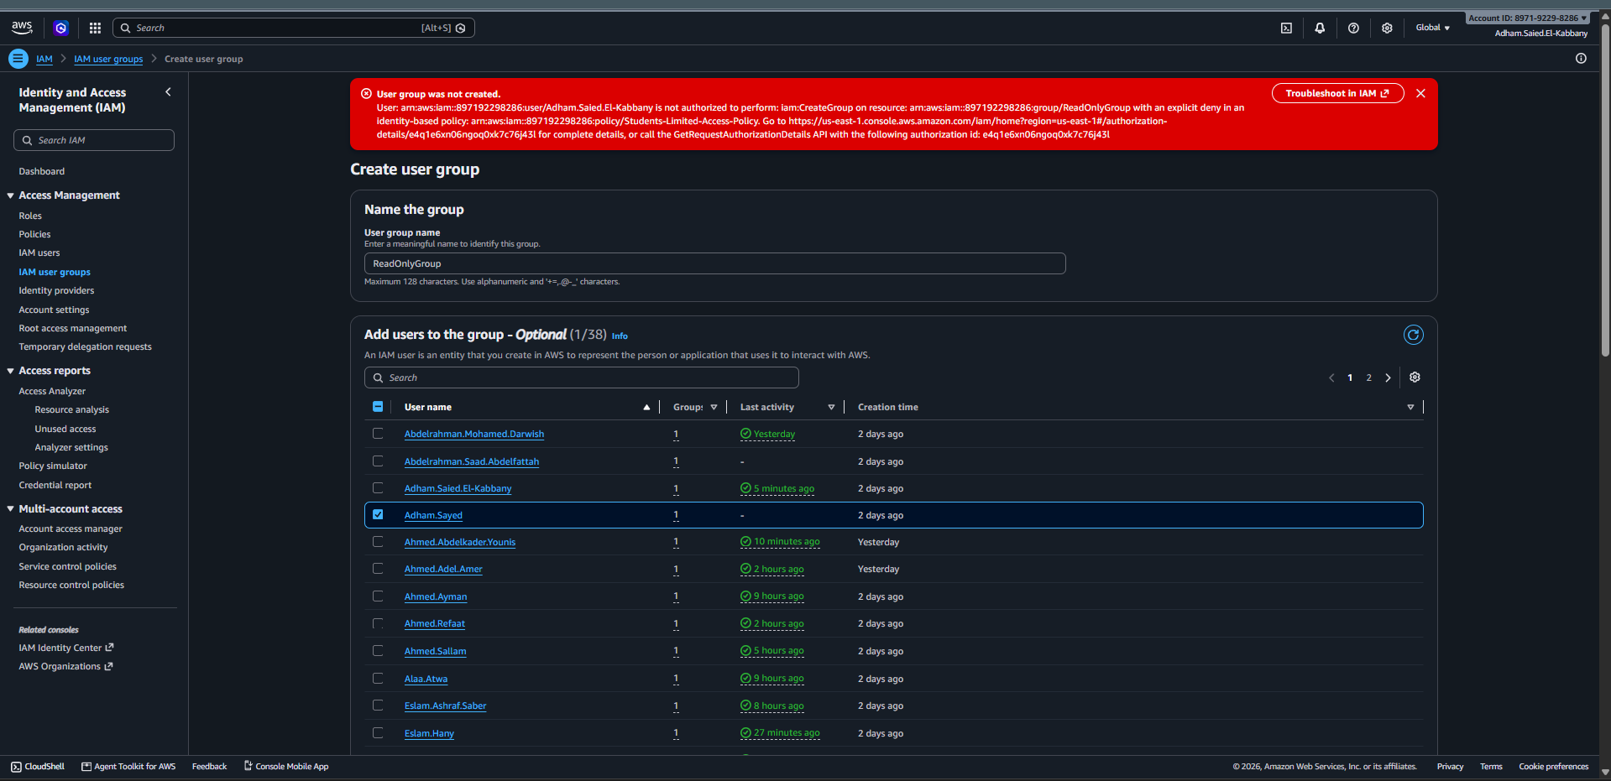

- Step 3 (Create a DevOps Role with Tag-Based EC2 Control) :
Go to IAM>Roles > create role, select AWS Service as Trusted entity type and select EC2 as Use case and then press next
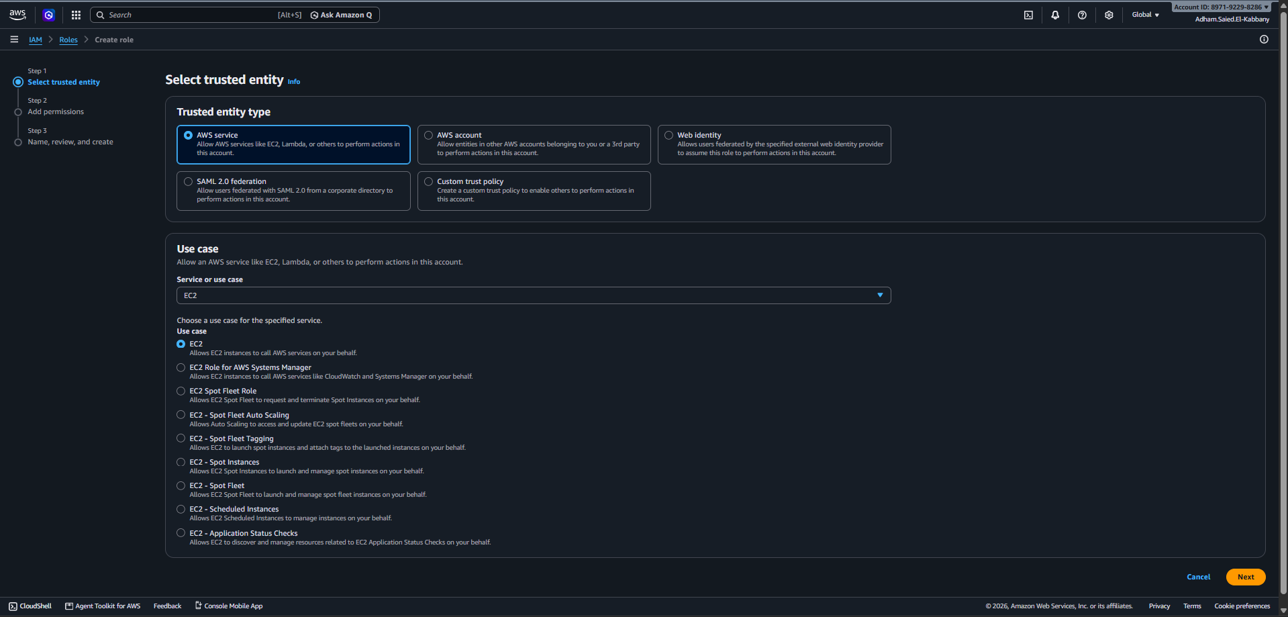

- I selected the AmazonEC2FullAccess policy when creating the DevOps role. This gives the role permission to manage EC2 instances. The access will later be limited to instances with the Env=Dev tag and protected with MFA.
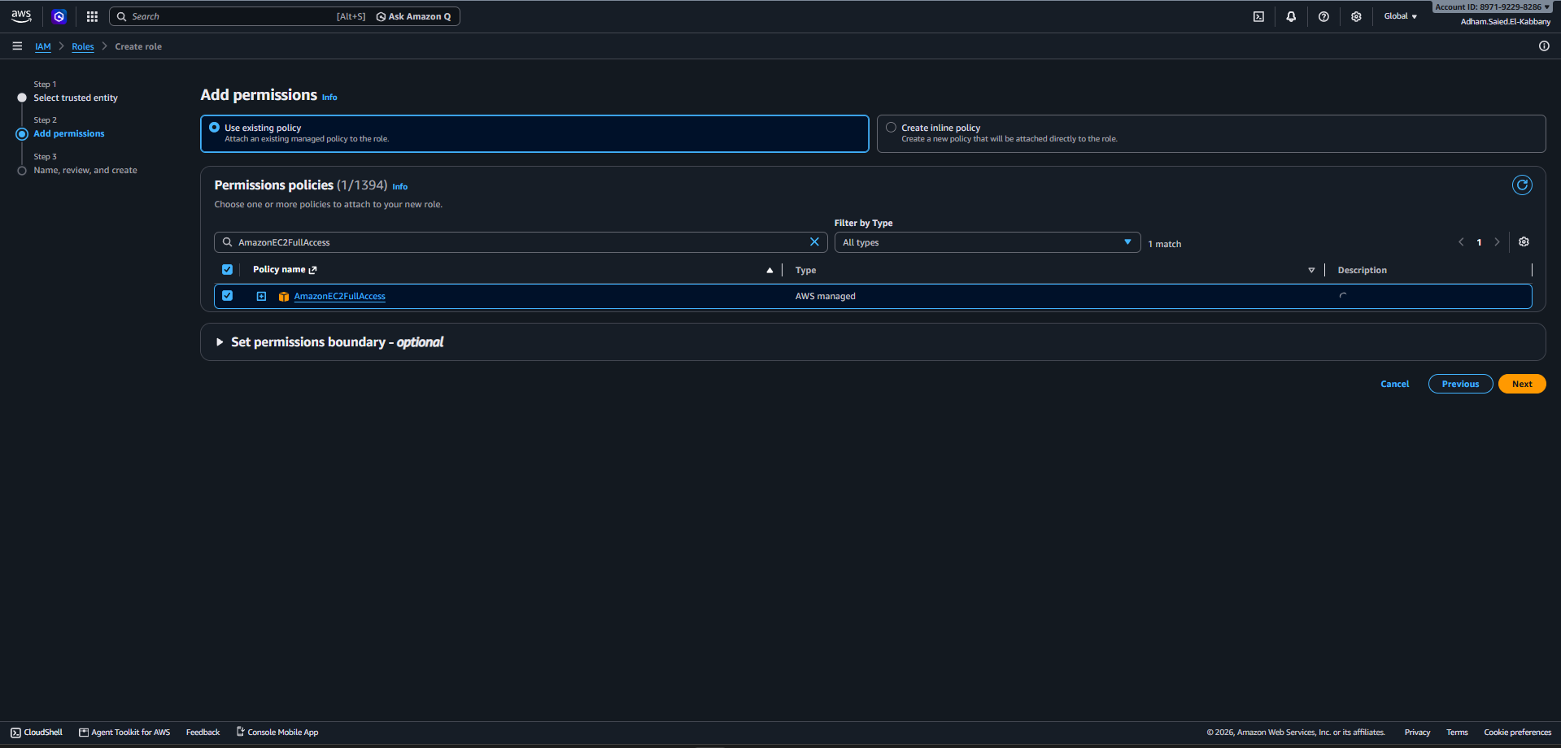

- I set the role name to DevOps-EC2-DevOnly-Role then edit the discerption and selected ec2.amazonaws.com as the trusted service. This completes the basic role setup before creating the role and adding the required conditions then press create role.
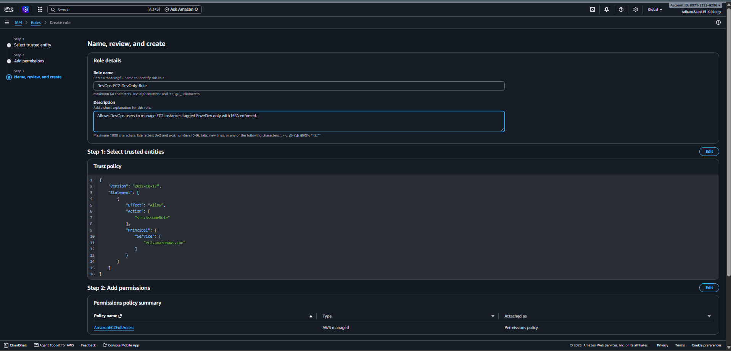

- The role was created successfully.
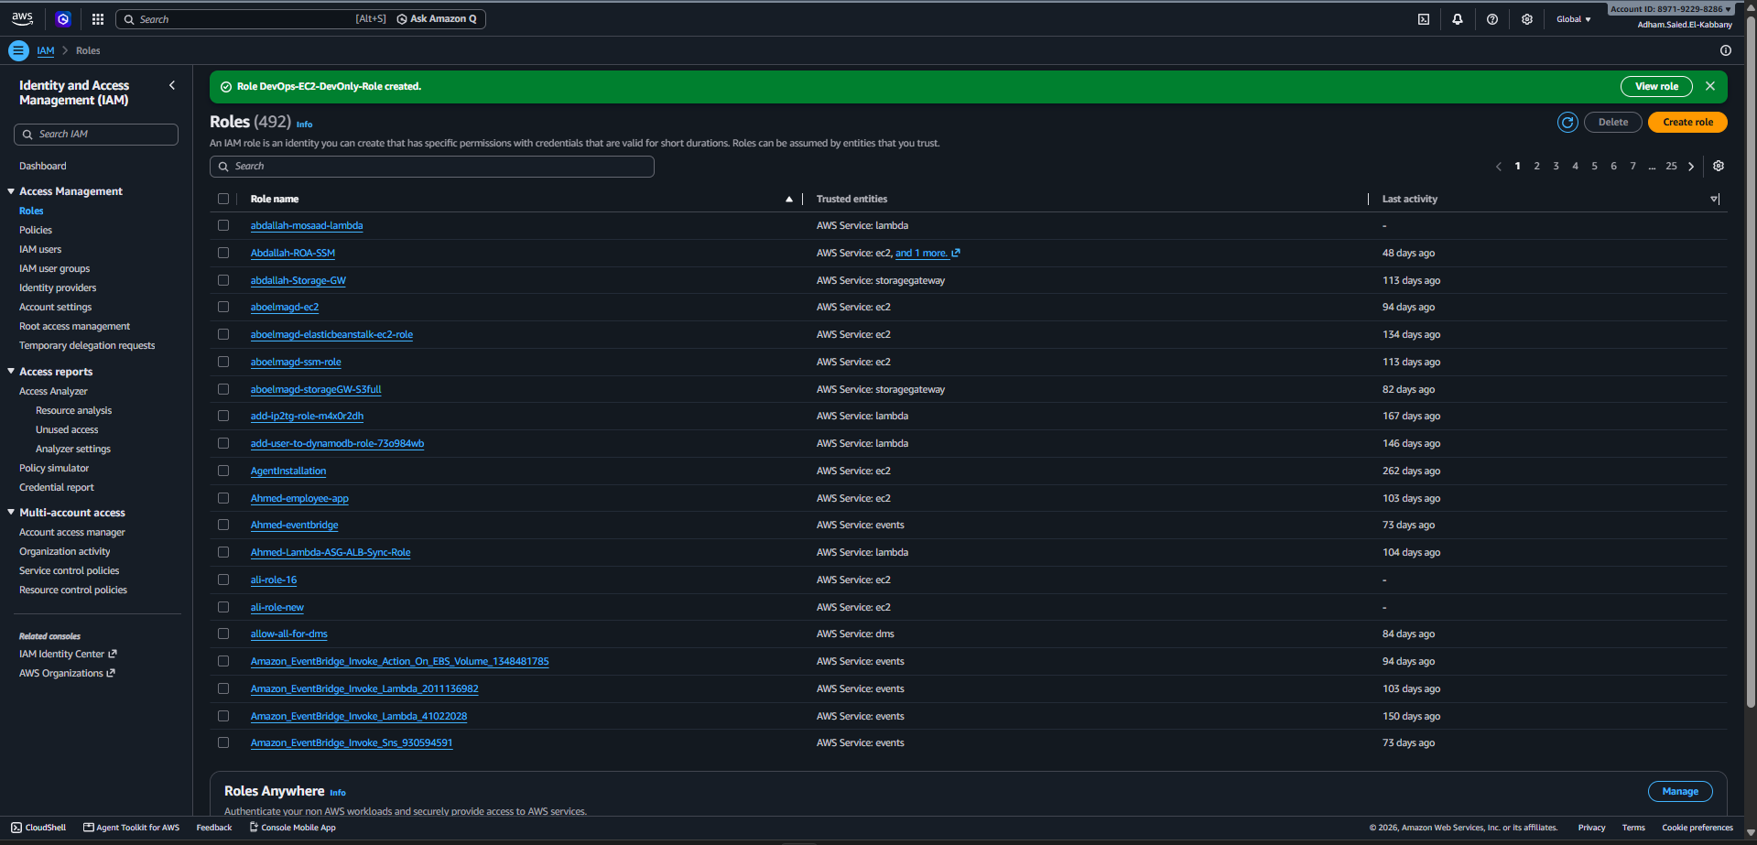

- Press view role and at permissions tab select add inline permission
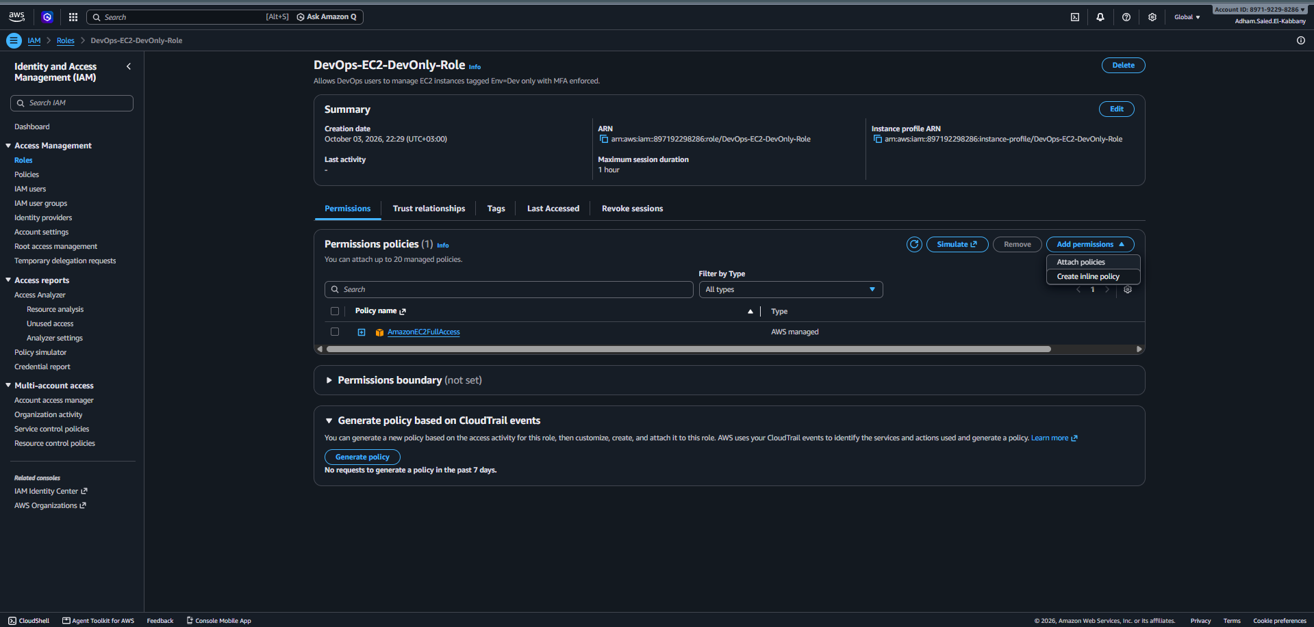

- I created and attached a custom inline policy called DevOps-EC2-DevOnly-Policy to the DevOps-EC2-DevOnly-Role. Policy Logic: Tag-Based Restriction: Allows Start, Stop, and Reboot actions only on EC2 instances with the Env=Dev tag. MFA Enforcement: Requires MFA to perform these actions. Least Privilege: Prevents the role from controlling instances in other environments, such as Env=Prod.

